Problem3

(a)

Plot of spins in different values of J

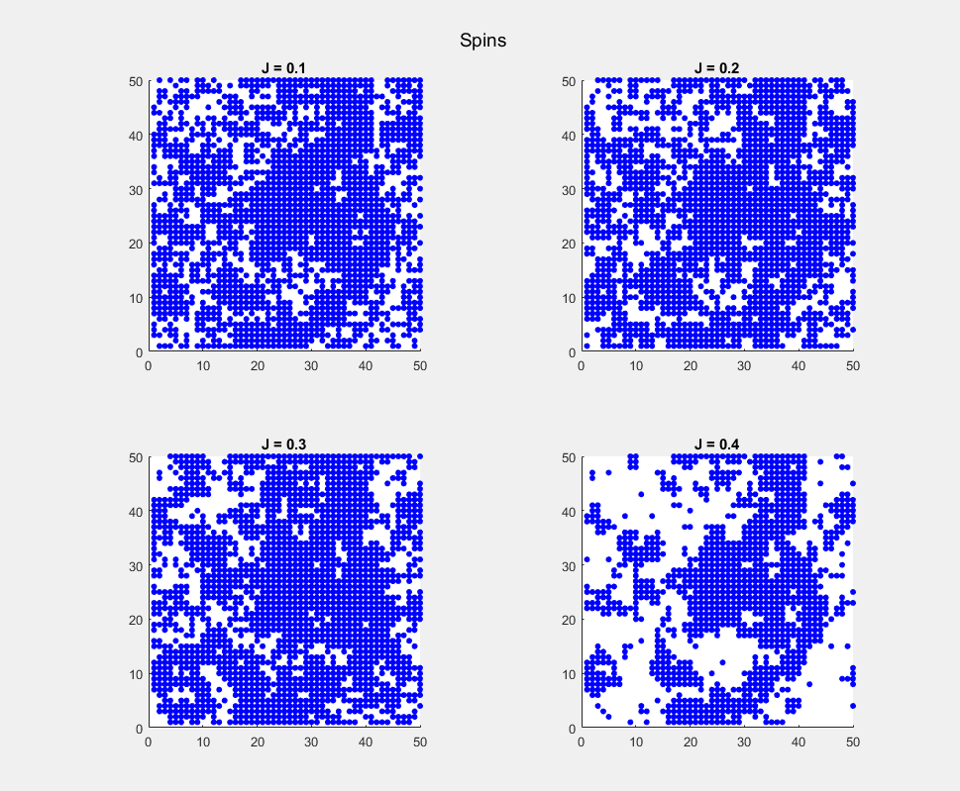

Plots of energy as a function of iterations in different J

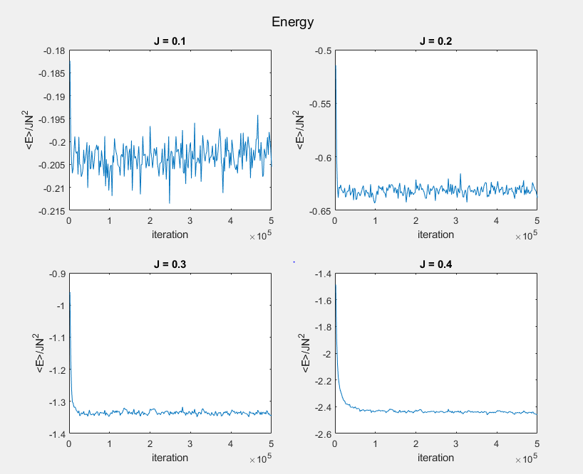

Plot of energy fluctuations as a function of iterations in different J

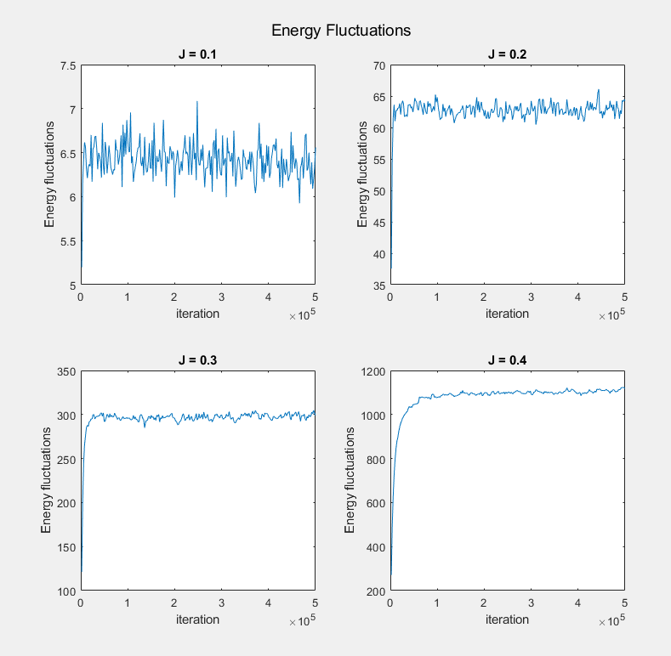

**From plot, we can find energy fluctuations significantly depend on J.**

(b)

We save the energy data and iteration data into excel. The values of A, B and for different J are presented in following table.

|  |  |  |  |
| --- | --- | --- | --- |
| J | A |  | B |
| 0.1 | 0.14 | 1056 | -0.20 |
| 0.2 | 0.48 | 1427 | -0.63 |
| 0.3 | 0.82 | 2523 | -1.34 |
| 0.4 | 1.21 | 5873 | -2.43 |

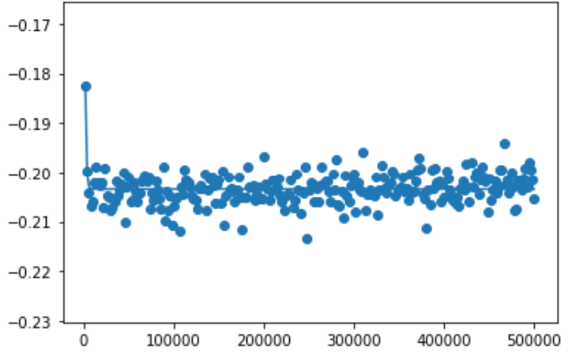

**Fitting plot for J= 0.1**

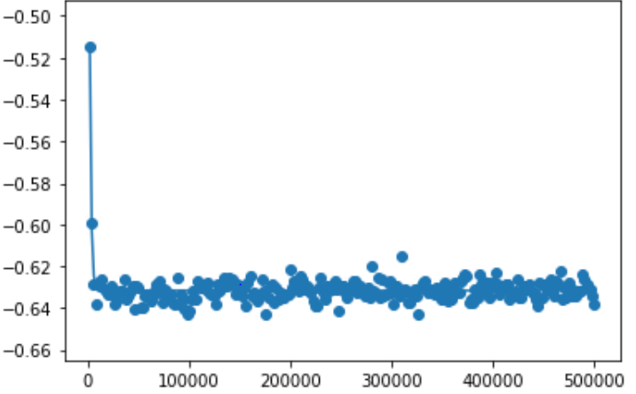

**Fitting plot for J= 0.2**

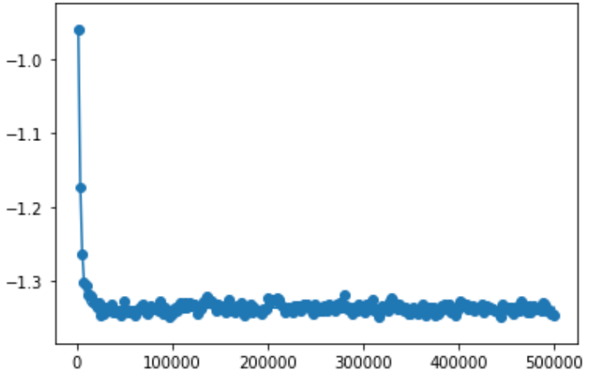

**Fitting plot for J= 0.3**

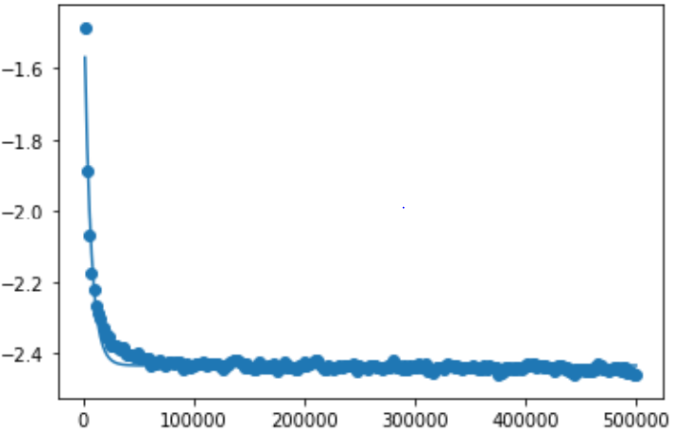

**Fitting plot for J= 0.4**

**From the data in table, we can find varies with different J**

(C)

|  |  |  |  |  |
| --- | --- | --- | --- | --- |
| J | A | m1 | B | m2 |
| 0.1 | -0.20 | 4.6e7 | 0.11 | 1234 |
| 0.2 | -0.63 | 1.31e8 | 0.46 | 1471 |
| 0.3 | -1.33 | -3.29e8 | 0.83 | 2498 |
| 0.4 | -2.41 | -3.32e7 | 1.26 | 5269 |

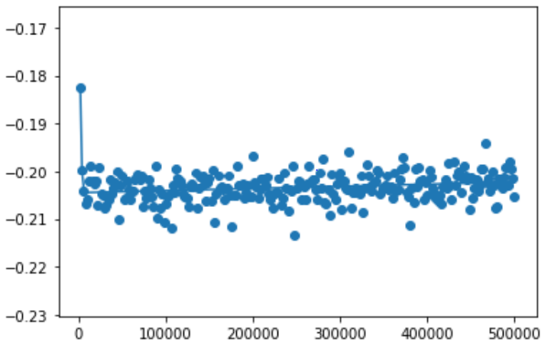

**Fitting plot for J= 0.1**

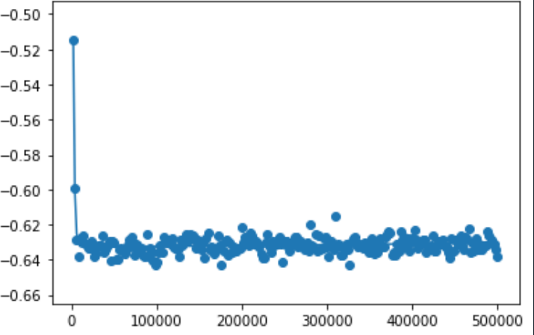

**Fitting plot for J= 0.2**

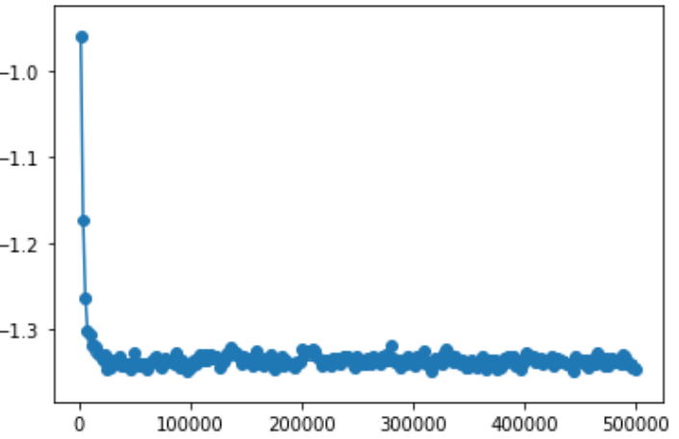

**Fitting plot for J= 0.3**

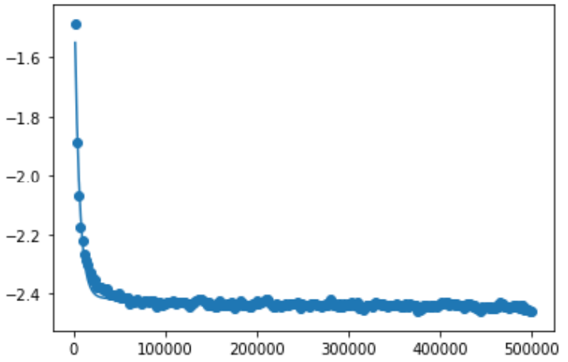

**Fitting plot for J= 0.4**

**We can find bi-exponential have a better fit with the data**

(d)

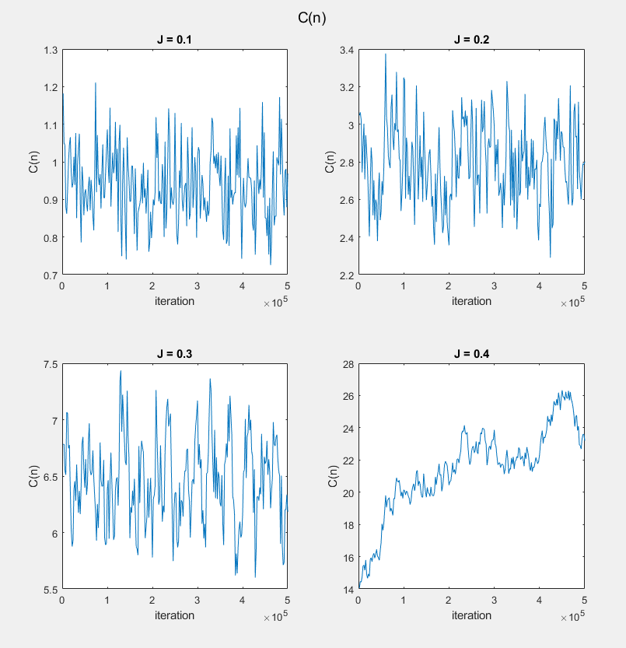

Values of Cn as a function of iterations in different J

We use the data simulated in problem3d in matlab, and we save the data in excel, then we do the data fitting in python. Results are presented as follow,

|  |  |  |
| --- | --- | --- |
| J | D |  |
| 0.1 | 0.95 | 1.55e7 |
| 0.2 | 2.79 | 5.99e11 |
| 0.3 | 6.47 | 1.54e8 |
| 0.4 | 21.5 | 6.30e13 |

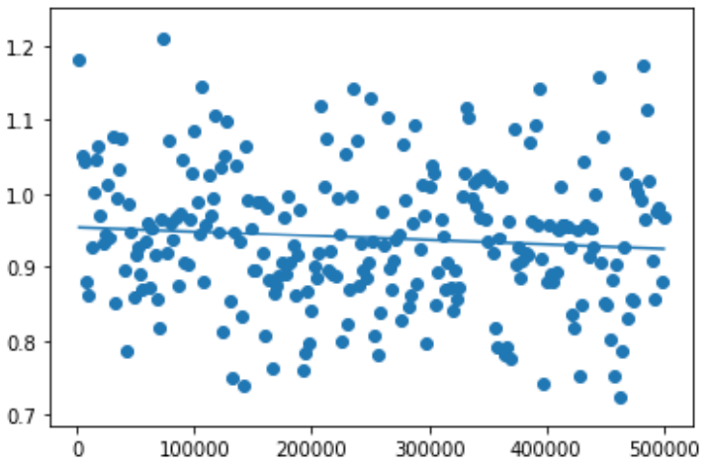

**Fitting plot for J= 0.1**

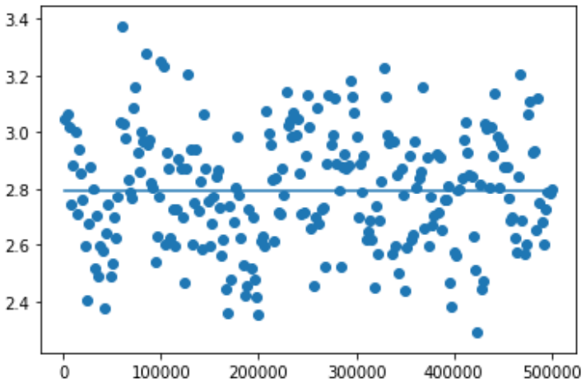

**Fitting plot for J= 0.2**

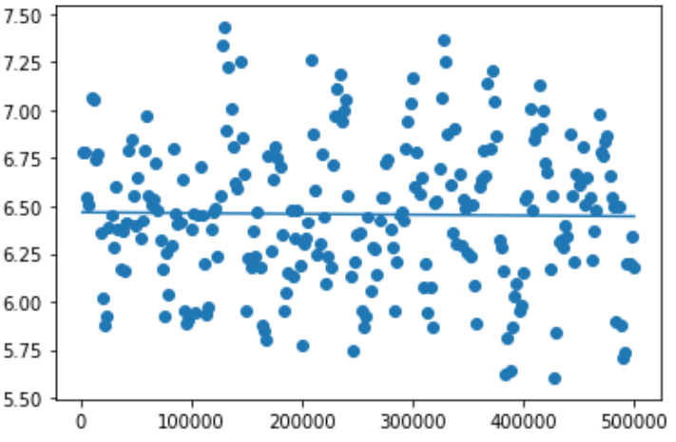

**Fitting plot for J= 0.3**

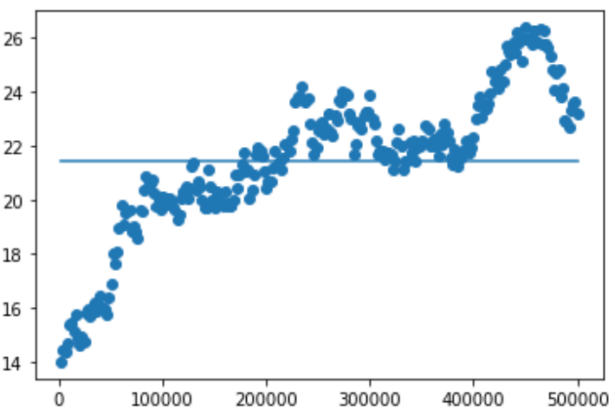

**Fitting plot for J= 0.4**

**Equilibration times are not the same as in the problem b**

(e)

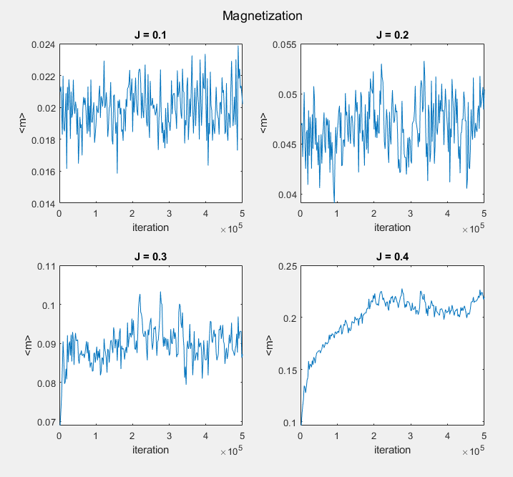

Plot of m in different j

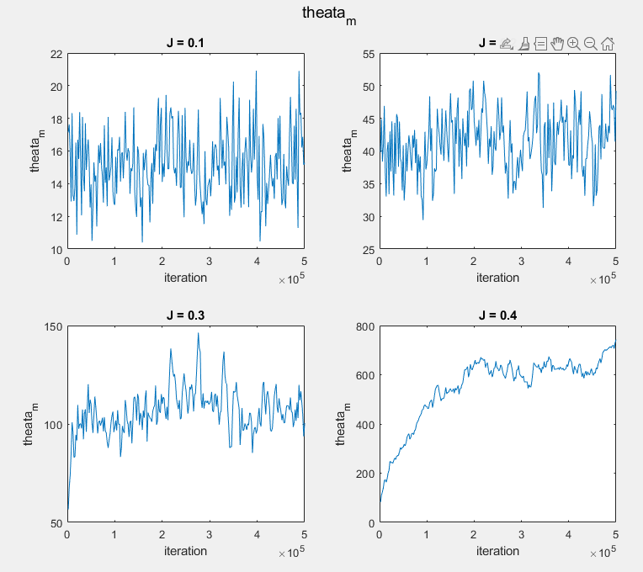

Plot of theata_m in different J